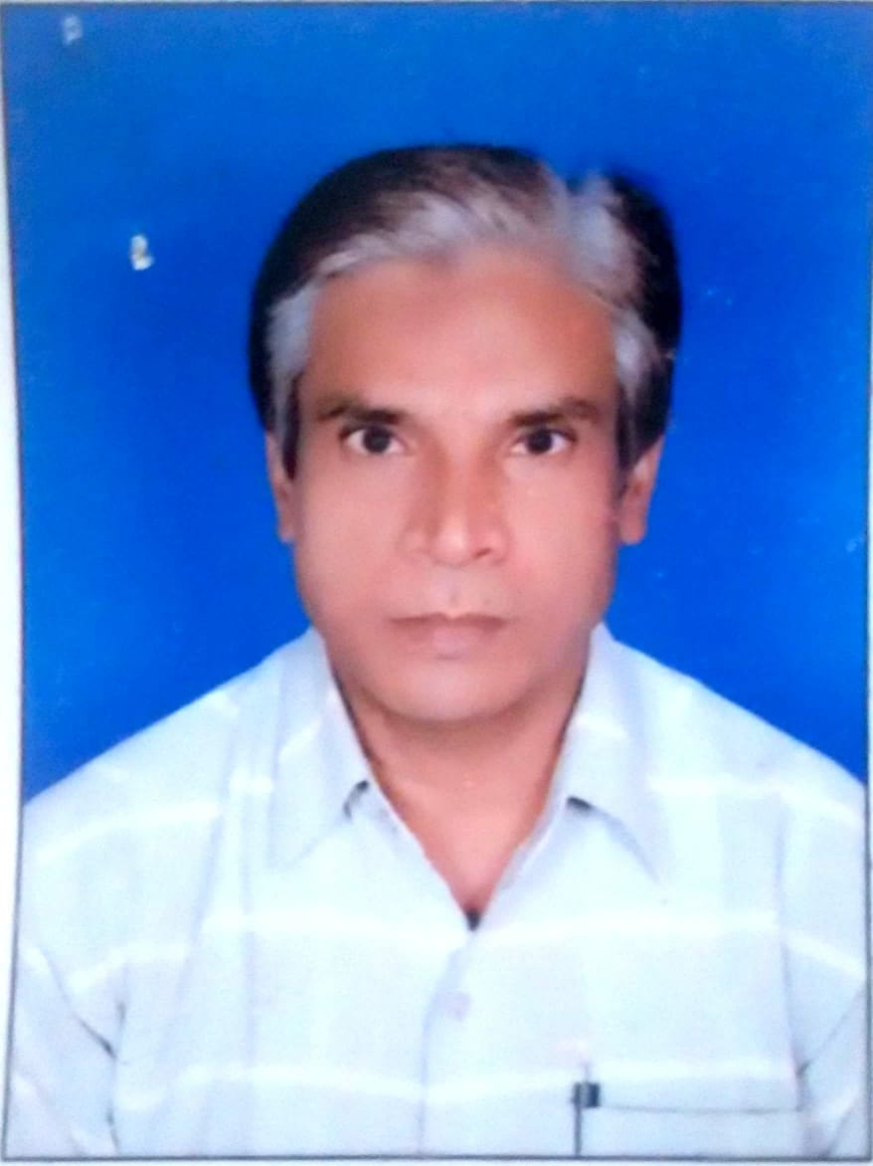
JECRC
Affix and Attest
passport
size photograph
JAIPUR

INDIVIDUAL TECHNICIAN DATA SHEET
Name of the Technical staff member | : | Rajendra Singh Naruka
Present Designation | : | Sr. Lab Instructor
Email Id: :narukaraj@gmail.com
Contact Details :9799060610

I. Particulars of Educational Qualification: (only completed)

Category | Name of the Degree | Specialization | Year of Passing | Name of the College | Name of the University
ITI | ITI | Fitter | 1989 | Govt ITI ,Bhundi | BTER

II. Academic Experience : 15 Year

III. Industrial Experience : 14 YEAR

